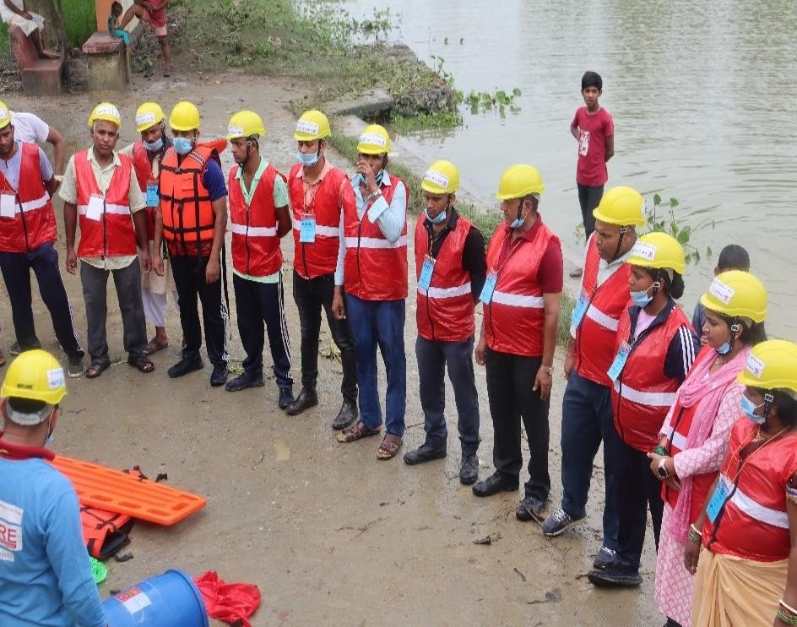
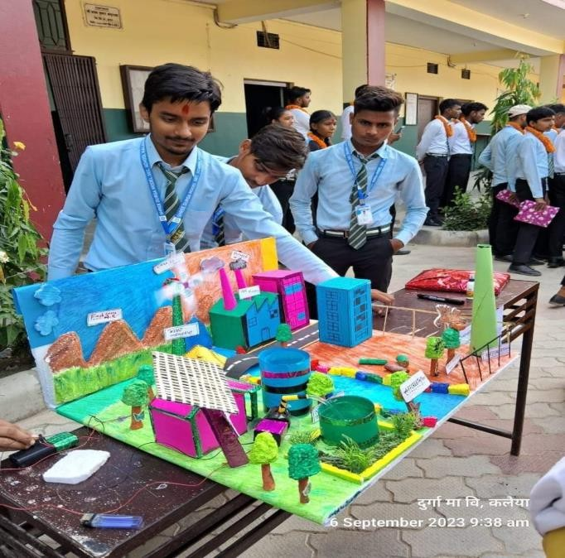
Organizational Profile, August 2026

Contact US





Kalaiya Sub- Metropolitian city ward No.- 1, Motibag, Bara Madhesh Province, Nepal
053- 590513

jjycbara@gmail.com

www.jjycbara.org.np



1



Introduction
Jan Jagaran Youth Club (JJYC) is a national not for profit, Humanitarian development non-governmental Organization. A group of youth from Telkuwa VDC, driven by passion to bring change into Terai/Madhesh community, came together to form the organization in 1998. , JJYC has program reach including phase out and ongoing in Parsa, Bara, Rautahat, Sarlahi, Dhanusha,Siraha, Saptari and Mahottari district of Madhesh Province , Morang from Koshi province, Gorkha from Gandaki, Makawanpur from Bagmati and Bardiya from Lumbini. It is lead and managed by youth committed to the development of Terai/Madhesh region of Nepal Since last 27 years, JJYC has been to achieve sustainable socio-economic empowerment and development of socially deprived and marginalized communities with funding support of various national and international partners. JJYC is governed by General Assembly which is held every year.
Rationale
Millions of the most vulnerable and marginalized community people are being left behind and denied the opportunity to survive with fulfill their potential, especially in Madesh province. JJYC believes in change and has set the motto that "Change is Possible". We are committed to build a better Madesh Province for and with youth and young people.
JJYC is established with the aim of mobilizing community youth aiming for making them as change agent in the society for social transformation of the most vulnerable and marginalized people. JJYC will continue to work both in development and building a resilient society.
JJYC will fight for ensuring fundamental human rights of the people through aligning development initiatives to support fulfilling the constitutional provisions of Nepal and the government's national goals, priorities, and commitments made in national and international forums. All development initiatives will align with government policies including the United Nation's Sustainable Development Goals (SDGs). Developing a self-reliant, prosperous, inclusive, and resilient Madesh Province will be the core development approach to building a better province through empowering and developing the most vulnerable and marginalized people.
JJYC respect and practice inclusiveness of young people’s and marginalized communities' voices. It if responsive to their needs. It also promoted youth and stakeholders' engagement in development discourse. JJYC is committed to innovation in its strategies and interventions. It follows collaboration and coordination with different levels of government to align its program and establishes synergy and coherence with government policies, structures, and processes with the aim of sustainability. It is believed to promote comprehensive investment opportunities under a partnership approach with different development agencies including the governments.

2


Objectives
Development of Equitable Society In Madesh Province.
Improving the lives of marginalized community, person with disability, women, youth and children ensuring
their fundamental rights through increasing their access to quality education, livelihood, health promotion
and sanitation, governance and climate change mitigation to develop socially just and resilient communities.
By 2027, the most vulnerable and marginalized community people are surviving, practicing their fundamental
human rights, being protected, and ensuring a self-reliant, prosperous, inclusive, and resilient Madesh
Province making the system and processes more responsive and accountable.

JJYC is committed to accomplishing the following objectives.
- To ensure inclusive education and a health system strengthened
- To build disaster and climate- resilient communities
- To ensure social transformation of the most vulnerable and marginalized people

JJYC strives to achieve the following specific objectives.
  - To ensure access to quality Inclusive Education and lifelong learning
  - To ensure Fundamental rights (Children, Women and Persons with Disabilities)
  - To support Marginalized and Vulnerable communities for their sustainable livelihood
  - To promote the health, nutrition, and sanitation of marginalized and vulnerable communities.
  - To ensure sexual and reproductive health rights (SRHR), maternal, neonatal, and child health.
  - To develop DRR, Climate-resilient communities and institutions.
  - To coordinate and collaborate with different tiers of governments and other institutions for responsive and accountable governance.
  - To reduce different forms of discrimination and violence (GBV, Child abuse, and labor, exploitation)

3

  - To empower marginalized and vulnerable communities to reduce social harmful practices (dowry practices, early childhood, and force mirage).
  - To work with different institutions and support relief, response, and humanitarian aid.
  - To support developing a safe and secure place for learning and protect marginalized and vulnerable people.
  - To promote opportunities for youth, women, and persons with disabilities for obtaining gender- responsive decent work and human dignity.
  - To develop youth/young people as change agent and engage, sensitize and empower them for community development.
  - To lobby and advocacy with government agencies for policy formulation, policy integration and transformation in to program
  - To provide psychosocial support to most vulnerable girls, person with disabilities and people at risk during emergencies
  - To work with media house (policy advocacy, visibility, community awareness and sensitization, leering sharing, information dissemination and messaging)
  - To promote parental engagement for education, health, livelihoods, Wash and other development initiatives
  - To initiate research and development work at different levels.
  - To enhance the practice of social and behavior change communication (SBCC) across all thematic areas of interventions.
  - To strengthen organizational capacities making an organization more professional, efficient, vibrant, innovative, competitive, and a learning-leading organization in Madesh province.
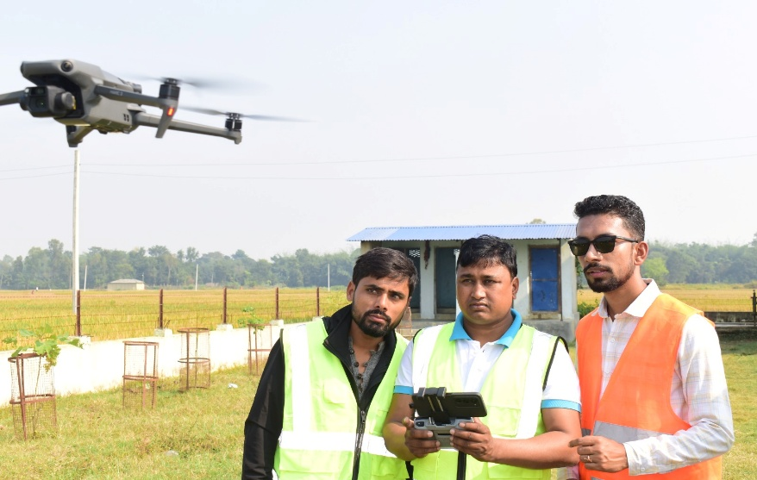


The development programs are guided by the following organizational core values.
- Inclusivity
- Integrity
- Transparency and Accountability
- Cooperation and Coherence
- Teamwork
- Protection and Safeguarding
- Volunteerism

- Inclusive Education
- Disasters resilience and climate change
- Gender Equality, Disabilities and Social Inclusion (GEDSI)
- Green and sustainable energy
- Sustainable livelihood
- Health promotion and sanitation
- Governance and accountability
- Youth engagement
4

- Human rights
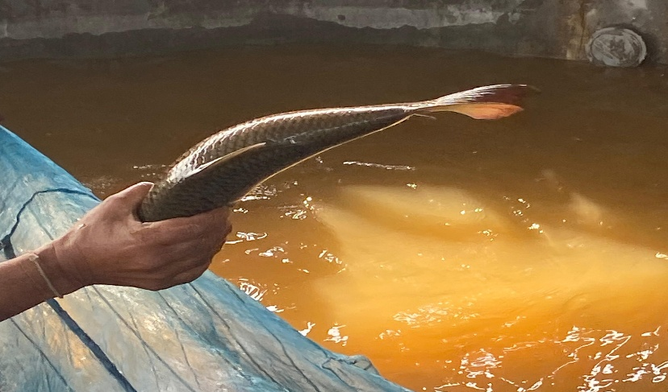
- Knowledge management (KM)

- Protection and safeguarding
- Humanitarian Aid
- Resilience and climate change
- Water Sanitation and Hygiene
- Gender Equality, Disabilities, and Social Inclusion (GEDSI)

JJYC has set several working strategies. To bring the desirable changes in society as per the constitutional spirit and the government priorities, JJYC works closely with different levels of government and other CSOs. Coherence with the government policies and priorities, relevance with the community, effectiveness in designing and implementing the project, efficiency in the management and delivery of the projects, and positive impact in more sustainable ways are the guiding principles to design and implement development projects. The following are some of the working strategies.
- Policy and Advocacy
- Participation, collaboration, coordination, and engagement
- Building and mobilizing networks and alliances
- Mobilizing volunteers for community development
- Enhancing local-level capacities
- Facilitating responsive and accountable governance
- Evidence-based planning and management



JJYC is registered as a non-governmental organization in District Administration Bara office and thus as per organizational policy, it has its own governing body. n JJ
YC's core values and principles, inclusivity has been well managed in the governing bodies. Gender, ethnicity, and language are taken into consideration. It has 7 members governing body.
S.N | Name | Position | Qualification | Experience | Representation
1. | Rajdev Sah | Acitng-  president | Bachelor  Degree | 15 years' experience in social  development and staff mobilization. | Development  Sector

5

2. | Siyaram Yadav | Treasurer | Bachelor Degree | 18 Years' experience in Gender equality , Social mobilization and Administration and finance  management. | - Finance and Accounts
3. | Basundhara Gaire | Acting Secretary | B.Ed | 15 years' experience in Cooperative management, Organizational Development Gender & Group  management | - Gender and social inclusion activist
4. | Jinnat  Jahan | Member | Intermediate | 7 years' experience in Inclusive | - Development  Sector
5. | Pramila  Chaudhari | Member | SLC | 10 years' experience in social  mobilization. | - Development  Sector
6. | Babulal  Majhi | Member | Literate | 15 years of experience in social work | - Development  Sector


JJYC has its policies to guide, manage and follow the organizational core values, principles, and ethics in the project cycle. JJYC's beliefs and practice of the rule of law, protection, and safeguarding, doing no harm while designing and implementing projects, zero tolerance to corruption, good governance, and accountability. JJYC has already developed and implemented the following policies, guidelines, procedures .

Law/policies | Guidelines and others
- By Law (Nepali & English (date)  - Anti-Fraud and Anti-Corruption Policy  - Anti-Sexual Harassment Policy  - Child Protection Policy  - Financial Management Policy  - Common Cost Allocation Policy  - Procurement Policy and Guideline  - Data Protection Policy  - Do No Harm Policy  - Human Resource Management Policy  - Gender and Social Inclusion Policy  - Internal Control Policy  - Monitoring & Evaluation Policy & Guideline  - Program Management Policy  - Risk Management Policy  - Safeguarding Policy  - Training & Capacity Development Policy | - Code of Conduct  - Salary structure in JJYC  - Responsibility Matrix  - Community Feedback Response Mechanism  - Complaints Handling and Investigation Policy and Guideline  - Organisational Strategy Paper JJYC_2023 to 2027  - Working Community and Beneficiaries Selection Guideline  - Advocacy Paper  - Social Audit guidelines  - COI declaration form.
6

- Volunteer Mobilization and Management Policy
- Whistle-Blowing Policy
- Conflict of Interest Policy
- Respect and Dignity at work Policy
- PSEA Policy
- Zero Tolerance Policy

S.N | Full name | Gender | Position | Brief Profile | Caste/Ethnicity
1 | Dr. Shriniwas Baitha | Male | Executive Director | Institutional development, Coordination and Collaboration with stakeholders, Social Mobilization Capacity development of staffs, Planning, implementation, monitoring and review of projects like peace building, Education and  Child rights in I/NGOs. | Dalit
2 | Umashankar Pd. Yadav | Male | Senior Project Coordinator | Coordination and Collaboration with stakeholders, Social Mobilization Capacity development of staffs, Planning, implementation, monitoring and review of projects like inclusive Education, WASH, Livelihood  and Child rights. | Madheshi
3 | Dipendra Gupta | Male | Admin and Finance  Manager | Admin and Financial Management, training, and quality assurance of  accounting. | Madheshi
4 | Naresh Pd Sah | Male | Program Coordinator | Coordination and Collaboration with stakeholders, Social Mobilization Capacity development of staffs, Planning, implementation, monitoring and review of projects like WASH, Livelihood and Child  rights. | Madheshi
5 | Trilok Kumar Mandal | Male | Project Coordinator | Coordination and Collaboration with stakeholders, Capacity development of staffs, Planning, implementation, monitoring and review | Madheshi
6 | Sanjiv Kr. Joshi | Male | Pedagogical Resource Person | Coordination and Collaboration with stakeholders, Capacity development of staffs, Planning, Education, implementation, monitoring and review | BC
7 | Kiran Neupane | Male | MEAL and Documentation Coordinator | , MEAL, Capacity development of staffs, Planning, implementation, monitoring and  review of projects. | BC

8 | Pawan Sahani | Male | AFO | Admin and Financial Management, training and quality assurance of  accounting. | Madheshi
9 | Mamata Kapar | Female | AFO | Admin and Financial Management,  training and quality assurance of accounting. | Madheshi
10 | Ram Suresh Thakur | Male | Education Project Coordinator | Coordination and Collaboration with stakeholders, Social Mobilization Capacity development of staffs, Planning, implementation, monitoring and review of projects like inclusive Education, WASH, Livelihood  and Child rights. | Madhesi
11 | Shah Hosen Hawari | Female | T4D coordinator | Technology for development, ICT | Muslim
12 | Santosh Kumar Sah | Female | Supply chain Officer | Supply chain and administration | Madhesi
13 | Abhishek Singh | Female | TVET Officer | Youth employment and TVET | BC
14 | Nisha Pant | Female | EPO | Social mobilization, Inclusive Education | BC
15 | Gauri Shankar Kumar Yadav | Male | TVET Officer | Youth employment and TVET | Madhesi
16 | Dilip Kumar Sah | Male | TVET Officer | Youth employment and TVET | Madhesi
17 | Mala Kumari Yadav | Female | EPO | Social mobilization, Inclusive Education | Madheshi
18 | Suneshwar Pd. Sah | Male | EPO | Social mobilization, Inclusive Education | Madhesi
19 | Renu Kumari | Female | EPO | Social mobilization, Inclusive Education | Madhesi
20 | Narendra Kumar Pasman | Male | EPO | Social mobilization, Inclusive Education | Madheshi
21 | Niruta Bishwakarma | Female | EPO | Social mobilization, Inclusive Education | Dalit
22 | Raj Narayan Ram | Male | EPO | Social mobilization, Inclusive Education | Dalit
23 | Nitesh Kumar Sah | Male | OA | Office administration and guest hospitality | Madhesi
24 | Sirmala Kumari Majhi | Female | CS | Office cleaning and kitchen | Dalit
25 | Bipin Yadav | Male | Sub-Engineer | Construction Specialist | Madheshi
26 | Prabha Giri | Female | Office attendant | Office cleaning store mgt. and guest  hospitality | BC
27 | Shashikant  Kushwaha | Male | AFO | Admin and finance | Madheshi
28 | Krishna Paudel | Male | Aquaculture Specialist | Aquaculture and fishery | BC
29 | Anjan Jaiswal | Male | AFC | Aquaculture and fishery | Madhesi
30 | Jitendra Yadav | Male | ATC | Aquaculture, trade and fishery | Madhesi
31 | Girdhari Pd Yadav | Male | AFF | Aquaculture and fishery , social mobilization | Madhesi
32 | Abhishek Bishwokarma | Male | AFF | Aquaculture and fishery, social mobilization | Dalit
33 | Nitesh Kumar Gupta | Male | AFF | Aquaculture and fishery, social mobilization | BC
34 | Jaikant Sahani | Male | AFF | Aquaculture and fishery, social mobilization | Dalit
35 | Amita Kumari Yadav | Female | Program Officer | Coordination and Collaboration with stakeholders, Capacity development of staffs, Planning, implementation, monitoring and review and sponsorship Mgt. | Madhesi
36 | Amit Kumar Sah | Male | SM | Social Mobilization | Madhesi
37 | Menka Yadav | Female | SM | Social Mobilization | Madhesi
38 | Kabita Yadav | Female | SM | Social Mobilization | Madhesi
39 | Sudip Chaudhary | Male | Sub-Engineer | Construction Specialist | Janjati
40 | Kiran Kumari Patel | Female | OA | Office administration, cleanings and guest hospitality | BC
41 | Dhirendra Chaudhary | Male | Youth Employment/TVET Coordinator | Youth employment and TEVT, capacity development staff | Janjati

8

 | Development partners/Donor |  | Projects |  | Projects geographical areas |  | Duration |  | Budget (NPR)
 | 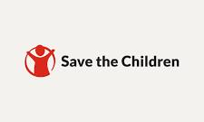 |  | Inclusive Nurturing System to Promote digital Innovation, job Readiness, and quality basic Education (INSPIRE) Project |  | Mahagadhimai Municipality, Devtal and Karaiyamai RMs of Bara district |  | 17th July to 31st December 2026 |  | 166,508,304. /-
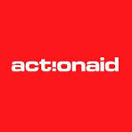 |  | Local Rights Programme |  | Aadarsh Kotwal RM, Bara district |  | 1st May to 31st December 2026 |  | 14,376,900 /-
 |  | Strengthening Maternal Neonatal Health Services in Partnership with the Local government |  | All Palikas of Bara district |  | 1st January to 31st December 2026 |  | 34,703,065./-
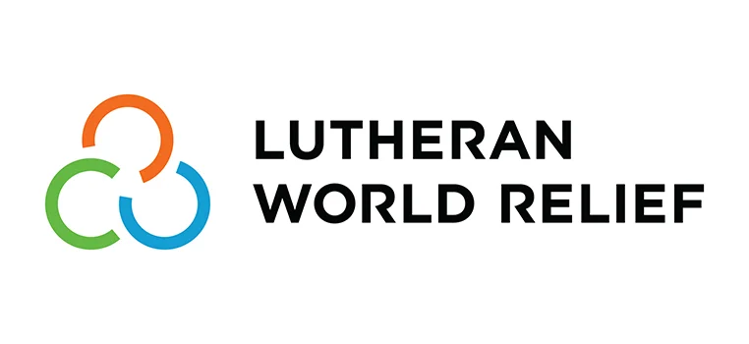 |  | Modernization Aquaculture Development in Nepal |  | Pacharauta, Simaraungadh and Kolhabi Municipalites of Bara, Garuda and Gadhimai Municipalities of Rautahat and Chandranagar and Godaita R/municipalities of Sarlahi district. |  | 22nd Dec, 2025 to September, 2026 |  | 7,997,912/-

S.N. | Projects
 | Education/Inclusive education
1 | SAHAYATRA (strengthening civil society for better resilience and inclusive  education governance in Nepal)
2 | Equal Access to Education for All
3 | Early Grade Quality Improvement Project
4 | Active Citizens Through Inclusive Volunteering and Empowerment (ACTIVE)
5 | Girls Education
6 | School as Zone of Peace
7 | Out of School program (OSP)
8 | Urban out of school program
9 | Parenting Education
10 | Women literacy
11 | Technical Support to local level Resource persons to implement ECD Center Plan through MSNP Budget.
 | Children, Women and People with disability
1 | Community Base Paralegal Project
2 | Women Rights, Responsibility and Advocacy Project
3 | Samyukta-Capacity Development of local government-Gaunpalika/Nagarpalika
4 | Gender sensitization
5 | Dalit empowerment project
6 | SAHAYATRA (strengthening civil society for better resilience and inclusive education  governance in Nepal)
 | Governance and Social Justice
1 | SUNDAR SHANT NEPAL (Peace building project)
2 | Community Mediation Project
3 | Ensuring Transparency, Accountability and Inclusiveness Through Public Expenditure Tracking Survey (PETS)
4 | Improving the Quality of the delivery of public services of selected agencies in Bara district.
5 | Increasing Social Harmony with Security and Good Governance
6 | Local good governance for effective service delivery
7 | Observation of Constituent assembly election
8 | Civic education for women
9 | Peace building and conflict transformation
10 | Building peace in Nepal; Ensuring Participatory and Secure Transition (EPST)
11 | Empowering Youths for Sustainable Peace and Democracy
 | Economic growth & Empowerment
1 | Poverty Alleviation

2 | Enhancing Livelihoods of Smallholder Farmers in Central Terai Districts of Nepal (ELIVES)
3 | Strengthening Smallholders Enterprise in Telkuwa and Rauwahi VDCs, Bara (SLVC I  )
4 | Strengthening Small Holder Farmers Organization for Livestock Value chain In Mahottai, Sarlahi and Bara District ( SLVC II)
5 | Social Mobilization and Resettlement Support to CMIASP
6 | Pig farming for Mushahar community
7 | Strengthening Community Resilience Project
 | Health, Water, Sanitation & Hygiene
1 | Implementation of Safe Water Supply Projects for Communities
2 | Rural Water Supply and Sanitation Project (Batch 7 to 10)
3 | Recovery and Reconstruction project
4 | Sustainable Sanitation and Hygiene for All (SSH4A)
5 | HIV/AIDS Street Drama
6 | COVID-19 Emergency Response to HCFs program
7 | Mobilizing Women Against HIV/AIDS
8 | Awareness on disinfection of water
9 | School based sanitation program
10 | Energy Sector Assistance Program (ESAP)
11 | Community Based Women Health Program
12 | Meena communication initiatives
13 | Child Nutrition Program
14 | Diarrheal Disease Control/ Acute Respiratory Infection (CDD/ARI)
15 | Breast feeding & Immunization Campaign
16 | Vitamin A Campaign
17 | Awareness Campaign on Iodized salt
18 | Eye Camp
19 | Deep Bore Water Project
20 | Nutrition Food Support Project
 | Humanitarian aid Support and Resilience community
1 | Tornado Response and Recovery project, 2019 Nepal
2 | COVID-19 Emergency Response program
3 | COVID-19 Preparedness and response (WASH) project for province-2
4 | Education in emergency support to flood affected children in Bara
5 | Relief distribution to tornado affected families
11

6 | Distribution of student- kits to the students of storm affected students in Bara
7 | Recovery and reconstruction projects

Thematic Area | Major Achievements
Education/Inclusi ve education  Location: Parsa, Bara, Rautahat, Sarlahi, Dhanusha, Siraha and Saptari districts | - GIAN formation, SSEP, SIP and Local curriculum development at 4 municipalities of Bara and Rautathat district.  - Strong coordination has been maintained with local and provincial government along with ETC, Madhes Province and respective district EDCU. Developed the capacity of 4 palika’s of Bara and Rautahat and assisted them for 10 years educational plan development.  - 10100 children including 85 children with disabilities provided with mentoring support and 341 children enrolled into schools through big sisters (27.4% have been changed in numeracy) Life Skill Marginalized and children with disabilities are now regular to school in support of big sisters.  - The policy of the working palika’s have been reviewed and mainstreamed the ECD, children with disabilities and the gender responsible budget planned and occurred the expense from palika.  - 11675 parents including 60 Person with Disabilities were reached and 2568 parents have built learning corner/space for their children at home, and they are regularly visiting to schools and supporting their children at home for reading and household chores have reduced.  - The schools have continued inclusive education fair in annual basis and Girls Inclusive Networks have been formed at school and Palika level.  - Schools had revisit and updated their SIP where the wash facilities, complaint response mechanism and gender responsive is focused and included the DRR and CCA and preparing the emergency plans.  - 266 local youths are capacitated and engaged to promote sanitation, climate change, girls' education and against harmful social norms. Due to the engagement of youths, parents and child clubs they have been greenery.  - The uses of plastic have been reducing by schools and also, they have did plantation and the result the environment is neat and clean of schools  - Active Complaint Response Mechanism at Schools  - Supported in Development of Comprehensive school Safety Plan to 10 schools.  - The policy of the working palika’s have been reviewed and mainstreamed the ECD and also the gender responsible budget planned and occurred the expense from palika.  - Strengthened the Early Grade classrooms as model classrooms and developed the capacity of the teachers on children holistic development though play based method teaching and use of low cost no cost materials at classrooms in project implemented districts.  - Psychosocial support and first aid training provided to schoolteachers and head teachers of Bara and Rautahat district.  - Parental awareness session conducted to continue the learning of children at home during  covid pandemic in Bara and Rautahat district.

12

- Mentoring support through community volunteers to most vulnerable children during pandemic
- Hand washing station installation for early grade children in 20 Schools of Bara and Rautahat and maintenance of 36 schools of Parsa and Dhanusha district.
- 63 resource persons are trained on MSNP ECD plan.
- 6 MSNP ECD plan of 6 Palikas in the targeted area.
- 81 Child club and 20 youth groups formed
- 42 young girls mobilized for community mobilization and support girls right to education.
- Child Clubs leading extra and Co-curricular activities at school and their leadership capacity has been developed and also Palika’s also allocated budget for weekly extracurricular activities.
- The ratio of school going girl child with boy is almost in balance
- SMC and PTA have become active and timely presentation and regularity of teacher in the school has been increased.
- The COs like child clubs, youth club, paralegal committee (PLC) members and others are mobilized in order to enhance the attainment of girls’ education in the community.
- Most of the schools are improved in establishing child friendly environment in the school.
- The other project like “implementing community-based paralegal program”, “School as zone of peace” are also coordinated with girls education program in order to increase the enrolment of the children and to enhance the quality of education in the project area.
- The concept of Parents Teachers Association (PTA) has been known to the political leaders/parents/community/teachers
- Schools which has been declared zone of peace, are not being used for personal, political, religious purposes.
- Monitoring Committees are formed among 55 schools and they are monitored their respective code of conduct and school regularly.
- Caste discrimination in the classroom has reduced among the students
Health, Water and Sanitation  Location: Bara, Rutahat, Makwanpur and Gorkha districts | - 56 schools hand washing stations maintained in Bara,Parsa, Rautahat and Danusha  - Establishment of Safe abortion canter in close coordination with District Public Health Office  - Technical Training to ANM and FCHVs on safe abortion.  - Capacity Building to Health Post In charge on Safe abortion and referral counselling.  - IEC material development and dissemination.  - HMIS data collection  - Frequent engagement of Local Government, DPHO and local health sector stakeholders.  - Disseminate information about safe abortion services and site available in Bara district among stakeholders.  - Orientation to community on Nutrition education and Nutrition Diet distribution  - Awareness rising to women on basic sanitation requirement.  - Community Awareness on causes of Diarrheal Disease and its control  - Aware Children on Diarrheal at school level  - Medical kits distribution in close coordination with DHO.  - BCG, Immunization vaccination and women education about CDDARI.  - Awareness rising on respiratory infection.  - Awareness rising to lactating mothers on importance of breast feeding.  - Assist the DHO in Polio drop distribution and campaigning.  - Vitamin A Campaign  - Assisted DPHO in Vitamin A capsule distribution.
13

- Data collection of the children having age for Vitamin A dose.
- Meena Communication Initiatives
- Video Documentary Presentation on sanitation and child education to all VDCs
- Response and feedbacks collection on understanding of documentary.
- Awareness Campaign on Iodized salt
- Iodized salt distribution to the families.
- Aware the people on importance of Iodized salt
- Awareness to retailers on sale of Iodized Salt
- Support Rotary Club in organizing the event in two places of Bara district.
- Take lead in overall management of Camp sight.
- Mobilizing Women against HIV-Aids
- Conduct HIV/AIDS related programs to WEP group
- Distribute all HIV/AIDS related program materials to WEP groups
- Assist district trainer in monitoring and supervise the group's activities
- Encourage other economic groups to replicate the WEP model.
- Document the success
- 39 Water Users Committees (WUC) were formed and registered in District Development Committee of three districts namely Bara, Rautahat and Makwanpur.
- 15 Social Audit conducted and 15 hoarding boards were placed in public places including all the planned budget and expenditures of the project
- 1632 members of the mothers’ groups were educated on sanitation, health and hygiene
- 403 pan seal toilets were constructed in the community households in Rautahat district.
- Ten Institutional latrines were constructed in Bagahi, Amarpatii and PiparabirtaVDCs.
- 204 Mothers' Child Tube well groups were formed.
- 15 Women Technical Support Service (WTSS) groups were formed and saving- credit program is regularly
- 125 women were involved in various income generating activities like vegetable production/trade, goat rising.
- NPR 527000/- Sanitation revolving loan fund was provided to users of 8 schemes and they are using the funds in toilet construction purpose
- 5432 women saved their time which they were wasted in fetching water and invested that time in other productive work
- 24 members of the water user committee were trained on institutional development.
- 40 members of the water user committee were trained on financial management.
- 8 Community Health Workers and 8 Village Maintenance Workers were trained to enhance capacity.
- 291 tube wells were installed for pure drinking water in various VDCs.
- 2110 community households of various VDCs were able to have safe drinking water.
- Former 17 VDCs of Bara district was declared as ODF having constructed toilets in 13950 households.
Children & women and people with disability Location: Parsa, Bara, Rautahat, Sarlahi, | - 980 most vulnerable children are supported with education materials.  - 600 parents are support with hygiene kit and orientation.  - 2400 children are supported with complete hygiene kits  - 210 hotel working children were counselled and made them to read and write.  - Hotel working children were encouraged to go school.  - 250 community people (parents) were oriented on child right.  - Community People were encouraged to reduce gender discrimination.  - Formation and mobilization of 81 Ward Level Child Club and 9 VDC Level Child Clubs.

14

Mahottari and Dhanusha District | - Level of awareness on child rights, child club management and leadership has been increased to 383 children.  - Level of awareness on various issues about child rights has been increased to 383 children.  - 630 women are actively engaged through 10 VDC Level Paralegal Committee (PLC) and 90 Ward Level Sub PLC to identify and solve the various issues on domestic violence, women and child rights abolitions and other social debates and are referring the complex cases to District Resource Group.  - 630 women of PLCs and sub PLCs are advocating and disseminating information against domestic violence, women and child rights.  - PLC members are creating pressure to VDC and DDC to comply the governmental provisions on budgeting process related to women and children  - PLC members are advocating for the better promotion of education for children and they have been involved to reaccelerate School Management Committee, Parents Teachers Association and School Administration. And they are realizing their responsibility and accountability towards better education.  - 345 cases registered and 322 solved and 23 in process by the PLC and DRG with the consensus of victims and victimizers.  - Women suffering from domestic violence of nearby VDCs started to visit PLCs for consultation and paralegal support.  - People awareness regarding legal rights and approach, the formal and informal justice mechanisms for accessing justice has increased remarkably.  - Coordination and linkages of PLC members with different district level line agencies increased which has made them easy to solve and refer the registered cases  - 630 women have been empowered to deal with legal and paralegal aspects related to  domestic violence, women and child rights.

15

Economic growth & Empowerment Location: Bara, Sarlahi and Mahottari district | - 2250 families are directly involved in goat farming & increase their income from nrs 15150 in yearly basis. They are rearing goats from improved goat rearing methods.  - 830 families are producing organic vegetable by using IPM technologies & making compost in their own households.  - 873 improved goat sheds have constructed in the project areas.  - 392 dairy animals' sheds have constructed & one Social Entrepreneur women cooperative have formed where 743 shareholders are involved & now also shareholders are increasing day by day. They cooperative have installing collection centre of milk & will start milk business.  - Facilitated in formation of 204 groups women led groups and they are actively engaged in income generation activities.  - Facilitated in formation of eight cooperatives and two collection centres which are running smoothly and NPR. 4,49,95,462.00 direct loan is disbursed by Cooperatives.  - BDS services as Insurance, Input supplies, technical services, and Collective Marketing is being continued by eight cooperatives.  - Fodder/Forage farming has done by goat groups members in 250 kathas of land of CFUGs.  - Different projects are implementing by cooperatives in support of local government and Business Micro finances.  - The smallholder farmers are supported through farm and nonfarm based trainings and equipment support for their food security and income generation.  - The lease land farming has been continued by the farmers groups for agriculture products like vegetables off and on season and fodder/forage.

16

Governance and Social justice Location: Bara and Parsa district | - Capacity development training on good governance to 45 civil societies’ representatives and 45 government line agencies’ representatives  - 15 members’ inclusive pressure group formation (government line agencies and civil society members) on good governance considering gender sensitiveness and disadvantaged group.  - Pressure group work as watch dog by advocating the equal distribution on allocation of resources  - Government line agencies and Civil Society Organizations started to involve representative of pressure group in each of their meeting which is concerned to public  - People started to complain to pressure group regarding the ineffective service delivery by government line agencies  - Pressure group started to visit different line agencies to make them accountable and responsible on people complains  - 83 different complains of different line agencies were put into action and solved Citizen Charter installed in all government line agencies  - Culture of public hearing had been initiated by different line agencies.  - “Why culture” developed in civil societies and people on good governance  - More than 100 youths have been trained and aware on the protection of rights  - More than 75 girls’ leaders of the sister organization of different political parties have been trained and aware on human rights  - Women and other stakeholders all over the district have been advocating on women and children rights.  - More than 100 youths have been committed for the implementation of human rights  - More than 100 young people have advocating for the timely constitution building.  - Among the participants almost 50 percent participation of the Dalit youths, this is encouraging.  - District level leaders of sister organization of different political parties committed abandoning private or fixed group interest and must concern national issues.  - District level pressure group has been formed by common consensus of all sister organization to create pressure on the national agendas.
Humanitarian aid Support and Resilience community Location: Bara, Sarlahi and Mohottari district | - Close coordination and collaboration with education cluster, District Disaster Management Committee and other stakeholders at the time of emergencies.  - 1510 students’ kits, 22 ECD kits and 114 school kits were distributed to 23 schools in Bara by tornado effect.  - 7120 student’s kits, 180 school kits and 71 ECD kit were distributed to 54 schools by flood effect.  - 6 palika of Bara, Sarlahi and Mohottari districts are supported for Covid 19 response in policy and physical support.  - 3 hospitals of Bara including provincial hospital is supported with oxygen cylinder, PPE sets and other required covid 19 medical equipment’s.  - 85 Covid affected vulnerable households are supported by one month food package.

17

Safe Migration  Location: Bara District | - Implemented Awareness raising street drama (New Life) project on HIV/AIDS in 75 VDCs of Bara district in partnership with USAID//Jhpiego Nepal  - Conducted 3 events of the street drama (225 events in total) in each 75 VDCs of Bara district. 17207 people (9430 males and 7777 females) were sensitized on HIV/AIDS from the targeted community for safe migration
JJYC currently owns the following assets:
- Financial Assets – multimedia, training, institutional development fund, membership fee,
- Social Assets - good will, network, credibility and community trust
- Human Resource : Education expertise – 5, Human rights, peace and democracy – 3, Health and sanitation – 5, Climate change – 1, Environment – 2, Entrepreneurship – 2, Agriculture & Livestock - 6 Gender and Social Inclusion -4, Human Trafficking - 1
- Physical Assets - Computer (Laptop 15, Desktop 2), Multi Media projector 3, Motorbike (4) Fax – 1, Camera DXL- 3, Printer-7 and others.

- Team culture: JJYC beliefs on teamwork and team culture. Working in a team, promoting team culture, and resolving issues through team consultations are common practices within the organization.
- Alignment: JJYC design and implement projects in each of them by aligning the projects with the organizations' vision, mission, goals, and government policies and priorities.

Acknowledgment and appreciation: JJYC acknowledged the work done by the employees' local community and always practice an appreciation culture while performing the work.
- Trust: JJYC trusts to the organizations' policies, vision, missions, and objectives. Likewise, we trust the people, and employees and respect their ideas and opinions.
- Performance focused: JJYC focused more on performance with evidences.

Protection and safety: staff protection and safety, direct beneficiaries' protection and safety is the major focus of the organization. JJYC is fully committed on protection and safety.
- Integrity, transparency and accountability: JJYC beliefs on integrity, transparency and accountability to be committed and responsive for good governance at all levels.

18

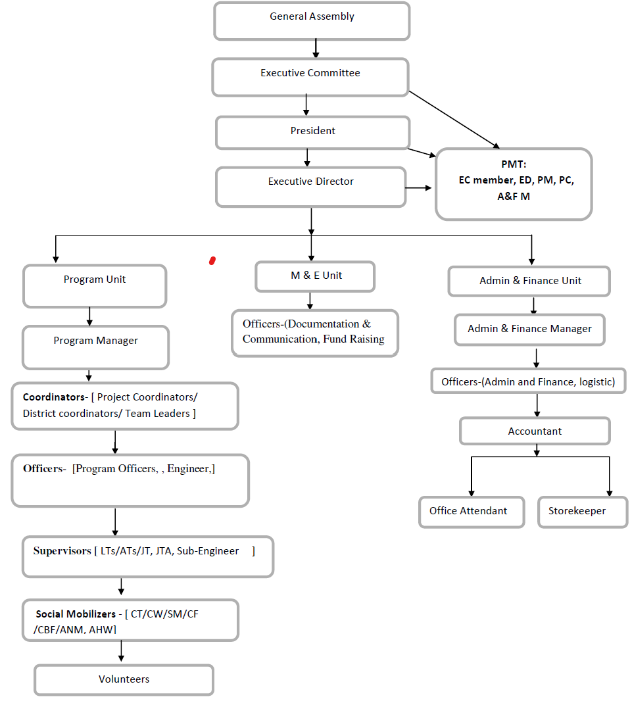

19

20

If you would like to know more about JJYC please visit www.jjycbara.org.np
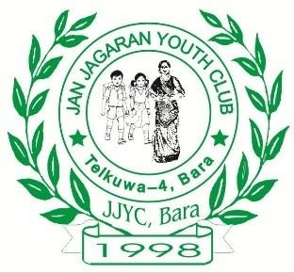
JAN JAGARAN YOUTH CLUB (JJYC) BARA

KALAIYA Sub-Metropolitan City-1, Bara  jjycbara@gmail.com

www.jjycbara.org.np 053-551513/590513
https://www.facebook.com/jjycbara

21

